**Report**

| Date | 31 July 2025 |
| --- | --- |
| Team ID |  |
| Project Name | Power BI Inflation Analysis: Journeying Through Global Economic Terrain |
| Maximum Marks | 5 Marks |

A report is a comprehensive document that provides a detailed and structured account of data analysis, findings, and insights. It is typically used for in-depth analysis, documentation, and communication of results. Reports are suitable for a diverse audience, including decision-makers, analysts, and stakeholders who need a comprehensive understanding of the data.

Designing a report in Power BI involves connecting to data sources, creating visualizations like charts and graphs, customizing their appearance and interactivity, organizing them logically on the canvas, formatting elements for consistency and clarity, and optionally creating dashboards for a summarized view. Throughout the process, it's essential to consider the audience's needs and ensure the report effectively communicates insights from the data. Finally, iterate based on feedback to continually improve the report's design and usefulness.

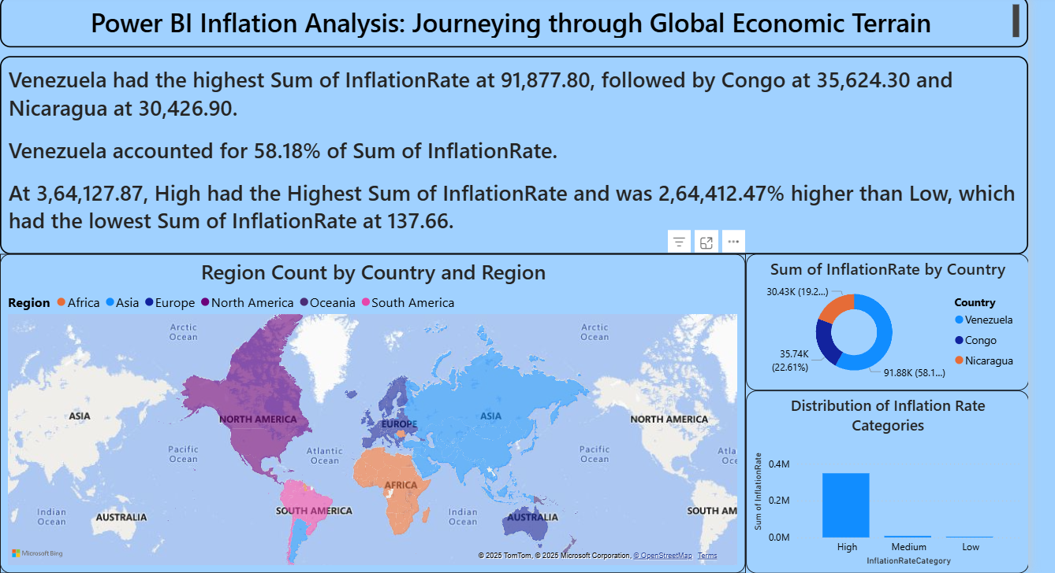

Observations drawn from reports in Power BI can provide valuable insights into business performance and trends.

### 1. Trends Analysis

* Power BI time series and trend visualizations reveal changes in inflation rates across years (1980–2024), highlighting both long-term patterns and sudden spikes caused by economic crises or policy shifts. This helps anticipate potential inflationary cycles and prepare for future economic volatility.

### 2. Performance Benchmarking

* Reports visualize how different countries and regions perform in terms of inflation control. For instance, South America and parts of Africa show significantly higher inflation rates compared to North America and Europe, enabling meaningful benchmarking between regions.

### 3. Anomaly Detection

* Outliers or extreme inflation cases—such as Venezuela’s hyperinflation—are quickly identified, allowing for deeper investigation into the economic and political factors behind these anomalies.

### 4. Continuous Improvement

* Regular monitoring of inflation trends provides insights into the effectiveness of economic policies. This feedback loop allows analysts to assess the impact of interventions like interest rate adjustments, currency reforms, and fiscal policies.

### Example Insights from the Dashboard

1. **Country Inflation Dominance**
   * Venezuela leads with the highest total inflation rate (91,877.80), far surpassing Congo (35,624.30) and Nicaragua (30,426.90). Venezuela alone accounts for 58.18% of the total inflation sum among the top countries.
2. **Inflation Category Comparison**
   * The “High” inflation category shows a total inflation sum of **3,64,127.87**, which is **2,64,412.47%** higher than the “Low” category (137.66).
3. **Regional Distribution**
   * South America and parts of Africa dominate the higher inflation spectrum, whereas North America and parts of Europe maintain consistently low inflation rates.
4. **Overall Inflation Distribution**
   * Most inflation falls into the “High” category, indicating a significant portion of countries have faced prolonged or extreme inflationary pressures in the dataset.